**Sales Prediction Using Python**

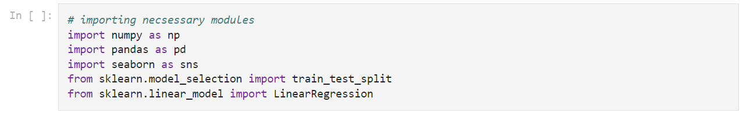





(200, 4)



TV 0

Radio 0

Newspaper 0

Sales 0

dtype: int64



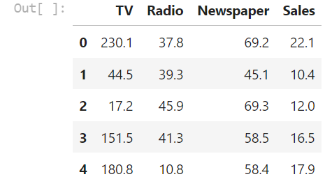



<Axes: >

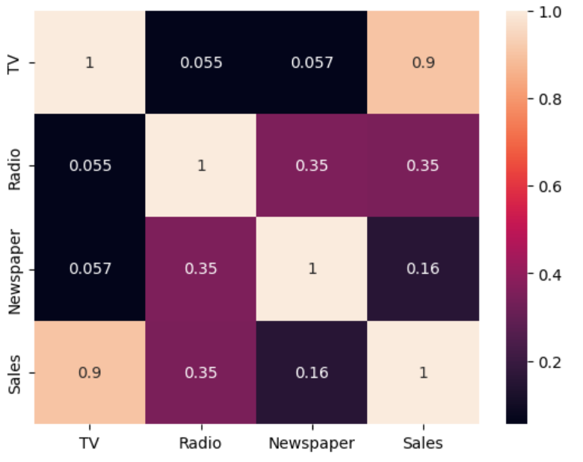



<seaborn.axisgrid.FacetGrid at 0x7b48017e7040>

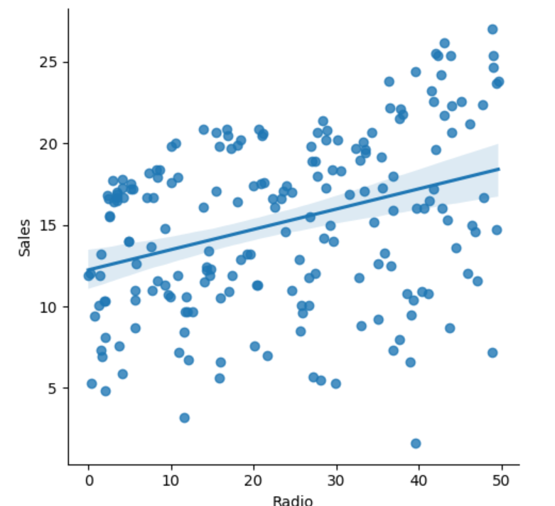



<seaborn.axisgrid.FacetGrid at 0x7b47ff382770>

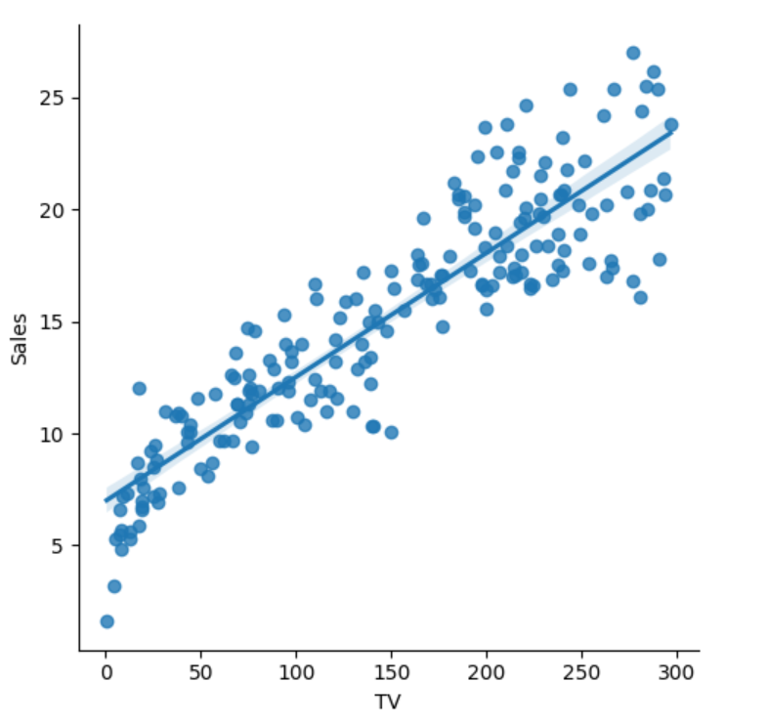



<seaborn.axisgrid.FacetGrid at 0x7b47ff3f0610>

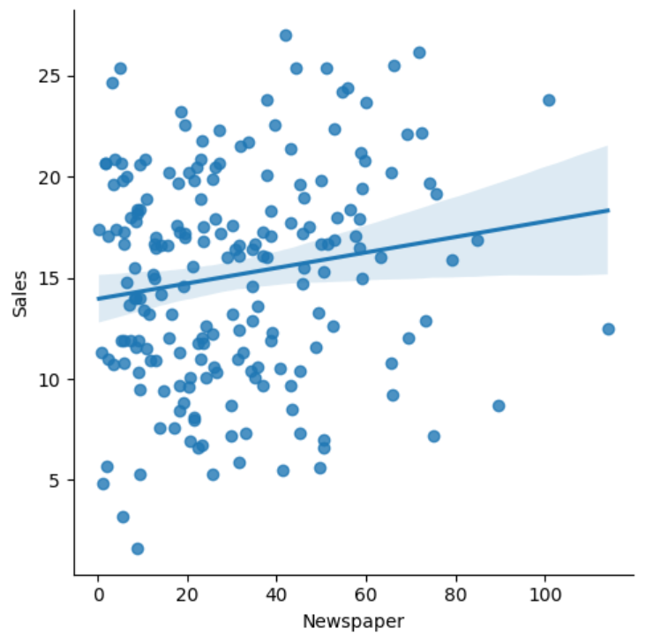

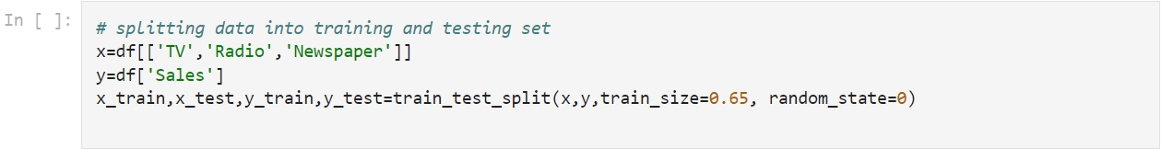

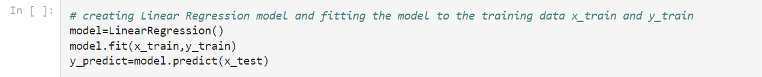



4.617647152872291

[0.05404987 0.11139369 0.00270166]

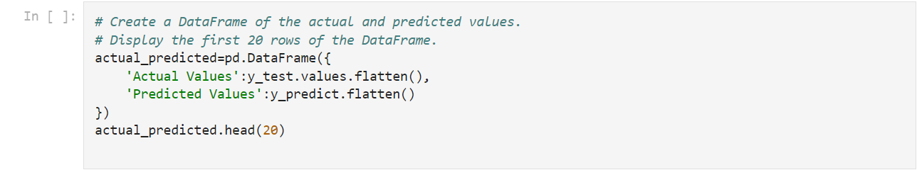

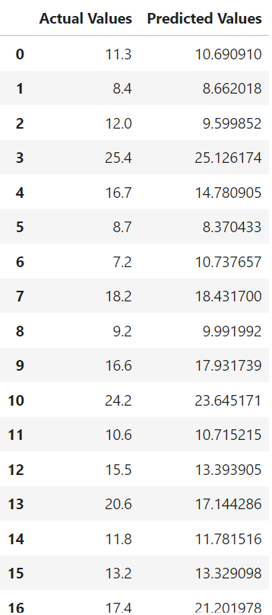

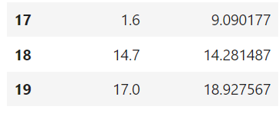



<seaborn.axisgrid.FacetGrid at 0x7b47ff297700>

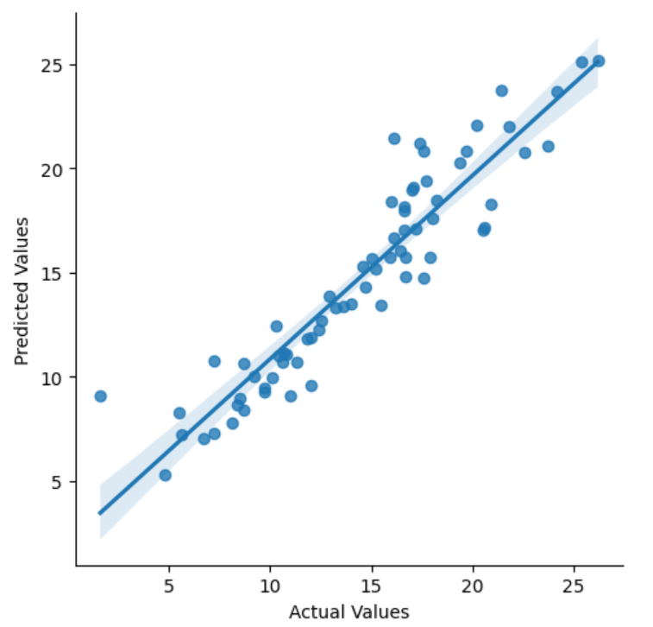



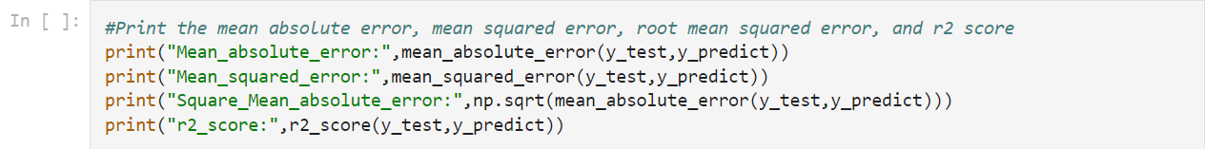

Mean_absolute_error: 1.3099256339323175

Mean_squared_error: 3.600552597855906

Square_Mean_absolute_error: 1.1445198267973855

r2_score: 0.8693105267585337



Accuracy: 86.93105267585337